|  |
| --- |
|  |
| 新概念 3 册 |
| Lesson22 By hearts |

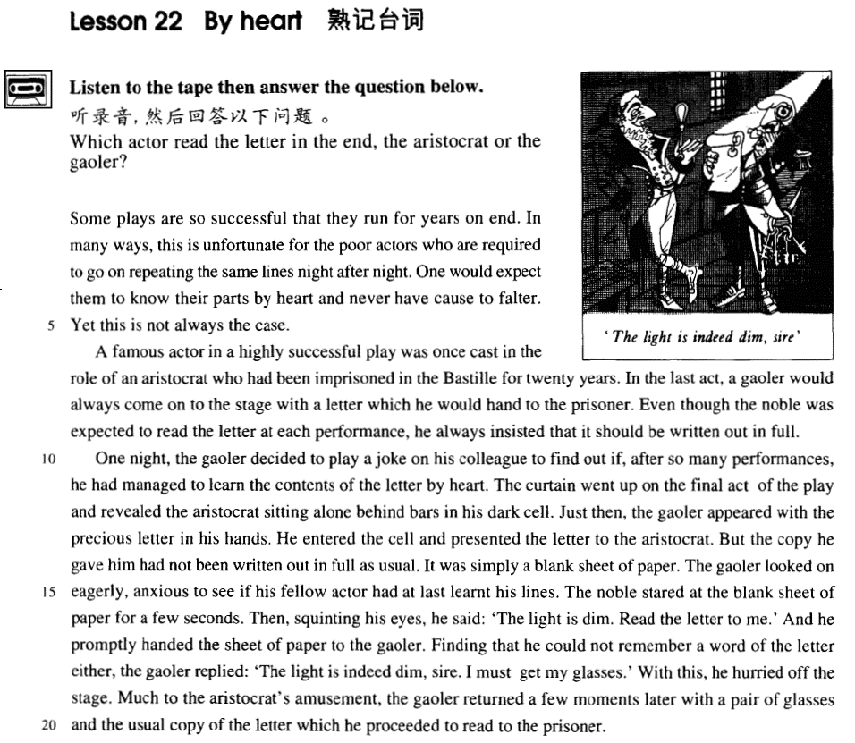

课文

词汇讲解

Lesson 22 By heart

**lines [laɪnz]**

**n. （演员的）台词**

**lines part role**

He plays the role / part of Hamlet. leading role supporting role hero / leading man

heroine / leading lady

cast an all-star cast

cast [kɑ:st] [kæst]

**v. 选派……扮演角色**

**be cast as / in the role of …**

He was cast as / in the role of Othello.

play / perform / act (the role / part of) …

He played / performed / acted (the role / part of) Othello.

play the lead in ...

Bruce Willis played the lead in ‘The Sixth Sense’.

star

Harrison Ford starred in ‘Air Force One’. ‘Air Force One’ starred Harrison Ford. **imprison [ɪm'prɪzn]**

v. 关押

**imprison sb. incarcerate sb.**

**jail / gaol sb. send sb. to prison put sb. in prison lock up sb.**

**be sentenced to …**

He was sentenced

to 10 years in prison. to life imprisonment. to death.

reveal [rɪ'vi:l]

**v. 使显露；揭示**

Her laugh revealed her even teeth.

reveal sth. to sb.

The doctor did not reveal the truth to the patient.

conceal sth. from sb.

The doctor concealed the truth from the patient.

expose

The soldiers were warned not to expose themselves.

squint [skwɪnt]

**v. 眯着眼看**

squint at … squint one’s eyes

peer at … peep / peek at … leer at …

He was always leering at female members of staff.

glance at … glimpse … gaze at …

**stare at … gape at … glare at … sire ['saɪə(r)]**

**n. 陛下（王室成员的尊称）**

Your Majesty

His / Her Majesty My Lord

Your Excellency

His / Her Excellency

proceed [prə'si:d]

**v. 继续**

proceed with … proceed to do … go on with …

go on to do … go on doing …

continue to do … continue doing … carry on with … carry on doing …

learn / know sth. by heart bear / keep sth. in mind make a mental note

remember / recall / recollect sth. remind sb. of sth.

bring back memories

Richard, these are terrific pictures. This one really brings back memories.

in retrospect

In retrospect, I think my marriage was doomed from the beginning.

… to remember

a day to remember

Gandalf, my old friend … this will be a night to remember. ring a bell

I haven't called Bill.

I don't recognize that name.

That doorbell doesn't work.

I didn't ring that bell.

That name just doesn't ring a bell with me. Answer: (B) I don't recognize that name. have a short memory

The man shouldn't have invited her roommate to the meeting.

Her roommate was unable to attend the meeting.

Her roommate is unreliable about delivering messages.

She forgot about the time change.

M: Why did you come to the meeting late? I left a message with your roommate about the time change.

W: She has a very short memory and it really gets on my nerve sometimes. Q: What does the woman imply?

Answer: (C) Her roommate is unreliable about delivering messages. The movie has been running for 2 months.

The movie has ended its run.

on end in a row

**successively**

She rearranged the chapters of her book.

She assured him that the chapter was finished.

She worked on the chapter for quite a while.

She wasn't sure how to end the book.

W: Did Linda ever finish that introductory chapter? M: I'm not sure. She's spent hours on end rewriting it. Q: What does the man imply about Linda?

Answer: (C) She worked on the chapter for quite a while.

She wishes the rain would stop soon.

She doesn’t care about the weather.

She’ll go out after the rain stops.

She expects it to rain for four more days. M: It’s raining again.

W: This makes it four days in a row. Do you think it’ll ever stop? Q: What does the woman mean?

Answer: (A) She wishes the rain would stop soon.

In many ways, this is unfortunate for the poor actors who are required to go on repeating the same lines night after night.

in many ways

in many respects in many aspects

in more ways than one

Considering the amount she paid, he was dear in more ways than one.

require sb. to do request sb. to do

You’re required not to smoke here. You’re requested not to smoke here. go on doing

keep (on) doing night after night night by night

one night after another **know / learn sth. by heart learn sth.**

Our vicar is always raising money for one cause or another, …

the case: a true situation 实情

This is not always the case. This is indeed the case.

This is not the case at all. This might not be the case.

This is not necessarily the case.

A famous actor in a highly successful play was once cast in the role of an aristocrat who had been imprisoned in the Bastille for 20 years.

highly successful

a highly successful Academy

… was once cast as an aristocrat

… once performed / played / acted (the role / part of) an aristocrat had been jailed / gaoled √

had been incarcerated √ had been locked up √ had been sent to prison X had been put in prison X

In the last act, a gaoler would always come on to the stage with a letter which he would hand to the prisoner.

act 幕

**scene 场**

It happens in Hamlet, Act 3, Scene 1.

come on

There was great applause when the Russian ballerina came on.

appear

He scored only two minutes after he'd come on.

… with a letter and he would hand *it* to the prisoner.

… with a letter to hand to the prisoner.

Even though the noble was expected to read the letter at each performance, he always insisted

*that it should be written out in full*. be expected to do

be supposed to do should do

He's supposed to go to the meeting.

He wants the woman to give George the message.

He doesn't know why George can't attend the meeting.

He forgot to deliver a message.

W: Do you know if George is coming to the meeting?

M: Oh, no, I was supposed to tell you that he is sick and can’t come. Q: What does the man mean?

Answer: (D) He forgot to deliver a message.

表示 “建议, 要求, 命令”动词后的宾语从句中用 (should) do

**order, ask, decide, demand, require, advise, recommend, suggest, insist …**

He suggested that we (should) help them with English.

The teacher ordered that the homework (should) be finished within half an hour.

insist on …

…, he always insisted on *its being written out* in full.

One night, the gaoler decided to play a joke on his colleague *to find out if, after so many performances, he had managed to learn the contents of the letter by heart*.

play a joke on sb.

He added that a student had dressed up as a policeman and was playing all sorts of silly jokes on people.

play a trick on sb.

He played a trick on his wife, but she beat him up. kid (sb.) / joke

Are you kidding (me)? Are you joking?

have a joke with sb.

I’ve just had a joke with the manager.

make fun of sb.

The other children were always making fun of him because he was fat.

make a fool of sb.

I suddenly realized that I was being made a fool of.

play the fool (with sb.)

Stop playing the fool (with me). You’ll fall!

The curtain went up *on the final act of the play* and revealed the aristocrat sitting alone behind bars in his dark cell.

the curtain goes up / rises

the curtain comes down / falls The curtain rose …

draw / pull the curtains open / close the curtains on the final act

in the last act

alone / on one’s own / by oneself

She was sitting alone on a park bench.

I don’t like walking home on my own at night.

Do you share the apartment or do you live by yourself?

*all* (alone / on one’s own / by oneself )

Wendy was frightened, *all* alone in that big old house. oneself

Then I added with a smile,' It's a strange mixture I make myself.' Lesson 46 Do it yourself

I would not hear of the suggestion and said that I would fix it myself. lonely / lonesome

lonely hearts ad

Are you lonesome tonight? Do you miss me tonight? Are you sorry we drifted apart?

present sth. to sb. present sb. with sth.

When Dickie was given the watch, he presented the assistant with the cloth bag. He entered the cell and presented the aristocrat with the letter.

But the copy he gave him had not been written out in full *as usual*. as usual

Sam was in a bad mood as usual. as ever

as always like always

The gaoler looked on eagerly, anxious to see if his fellow actor had at last learnt his lines.

look on stand by

Only one man tried to help us, the rest just looked on / stood by in silence. onlooker bystander

look on … as …

We look on her as a daughter. stand by sb.

He stood by her through the difficult times.

… anxious to see if his fellow actor had at last learnt his lines.

= … being anxious to see if his fellow actor had at last learnt his lines

Ashamed of having acted so rashly, Dimitri apologized to Aleko for having accused him.

= Being ashamed of having acted so rashly, Dimitri apologized to Aleko for having accused him.

be anxious / eager / impatient / itching / desperate / dying to do … can’t wait to do …

Alf did this for over two years and his fellow dustmen kept his secret. fellow students

And so, my fellow Americans, ask not what your country can do for you; ask what you can do for your country. — John F. Kennedy

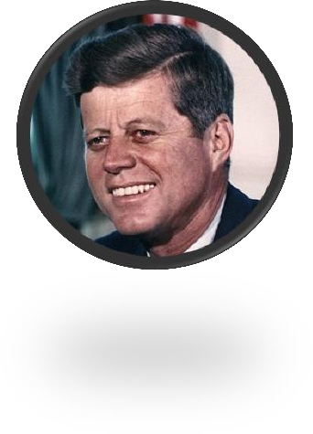

learn / know sth. by heart

learn sth.

know their parts by heart

learn the contents of the letter by heart learn his lines

read sth. to sb. read sb. sth.

Read me the letter.

Then, he squinted his eyes and said: ‘the light is dim. Read the letter to me.’

汉语：parataxis—平行语，连动句，没有轻重之别。

**英语：hypotaxis—层次语，突出中心动词，次要动词状语化。**

Then, he squinted his eyes and said: ‘the light is dim. Read the letter to me.’ Then, squinting his eyes, he said: ‘The light is dim. Read the letter to me.’

The gaoler found that he could not remember a word of the letter either, so he replied: ‘the light is dim, sire. I must get my glasses.’

Finding that he could not remember a word of the letter either, the gaoler replied: 'The light is indeed dim, sire, I must get my glasses.'

He looked at his watch and saw that it was one o'clock, but the bell struck thirteen times and then it stopped.

Looking at his watch, he saw that it was one o'clock, but the bell struck thirteen times before it stopped.

with the coming of spring

with the approach of Christmas with the outbreak of war

with the progress of science

with the evidence began to accumulate

As the evidence began to accumulate, experts from the zoo felt obliged to investigate, … Much to the aristocrat's amusement, the gaoler returned *a few minutes later* with a pair of glasses and the usual copy of the letter *which he proceeded to read to the prisoner*.

to one’s … 使某人……的是

to one’s amusement

to one’s surprise to one’s dismay to one’s delight to one’s sorrow to one’s excitement

**much to one’s … 使某人大为 to one’s great … ……的是**much to the aristocrat's amusement to the aristocrat's great amusement

…… and he proceeded to read it to the prisoner.

He violently beat the boy and the boy later died from his injuries. He violently beat the boy who later died from his injuries.

Ha said he had lost his watch, but it was not true. Ha said he had lost his watch, which was not true.